
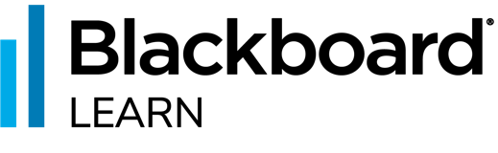
Blackboard Learn
Course Conversion
Before and After Conversion Checklist

Before Conversion Checklist

TASKS | STATUS

Announcements
Delete Unnecessary Announcements: Announcements are sometimes re-used every time the course is taught. In other cases, they’re used as one offs and will never be used again. You can use this as an opportunity to delete the announcements you don’t plan on using again before you convert your course.

Course Menu & Navigation
Review Depth: Ultra courses are limited to two levels of depth. You can have a folder at the top level with a folder inside of it. That’s as deep as Ultra courses can go. For example, Folder > Folder > Item. In Original, you can have unlimited depth. If you would like to simplify the clean-up up process post conversion, you should limit yourself to the following: Content Area > Folder > Item. Contents Areas (like our Home Page, Syllabus & Course Information and Course Content folders) are converted to folders and take up one of your allowed levels in Ultra.
Review Course Structure: If all your content in your Learn Original course content is within a single content folder (such as a Course Content folder), you may want to move all the contents to the Home Page of your Learn Original course. This is especially important if you have week/module folders within the Course Content folder.
Note: You may also consider creating learning modules for each week/module and moving the content from each week’s folder into the newly created learning modules. This will provide a 1-to-1 conversion in Ultra.

Course Content
Consolidate Content Items: Content Areas in Original Course View are typically viewed as Pages, where each Content Area is a page of content made up of individual blocks (Content Items, Assignments, Discussions, etc.). In Ultra, these become Folders and each item in the Content Area becomes a standalone item. Because of this change, it’s a good idea to consolidate Content Items within the same Content Area, folder, or learning module into a single Content Item.
In Original, folders were the recommended organization method. In Ultra, learning modules are now preferred. With learning modules in Ultra, you can add an image to module, add folders, and allow force sequencing if desired.

Folder: 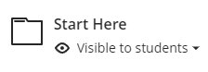
Learning Module: 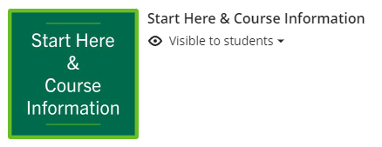

In Ultra, you can convert folders to learning modules (and vice-versa) automatically. To do so, click on the three dots to the right of the folder and select Change to Learning Module.
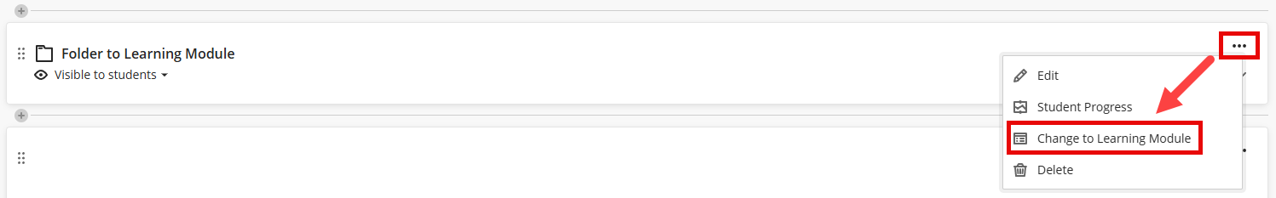
Review Descriptions: Descriptions are limited to 750 characters in Ultra courses and can only contain plain text (not formatting allowed). Please review descriptions on the following content types and ensure you’re only using plain text and less than 750 characters:
- Folder Descriptions
- Learning Module Description
- Lesson Plans Description
- Web Links Description
- Content Package (SCORM)
- Flickr Mashup Description
- Test Content Link Description
If you’re using multi-media, file attachments, or anything besides plain text in your descriptions, you may want to move those into a new content item to avoid it being dropped during conversion.
HTML Objects: HTML Content like embed codes are typically dropped during conversion. Make sure to backup those embed codes before conversion so that they can be recreated as HTML blocks in the Ultra Course View.
Note: Please review any Panopto Video placements to ensure they are placed correctly in the converted course.

Discussions
Review Discussion Forum Settings: Discussion Forums and Threads are converted differently based off the “allow members to create new threads” setting on Discussion Forums. You should review the conversion logic below and verify that the correct settings are applied to your Discussion Forums for your desired output.
- Discussion Forum is the Discussion Prompt: If the Discussion Forum is the Discussion Prompt, ensure that the “Allow members to create new threads” is selected. The Discussion Forum will be converted to a Discussion. All Threads in the Discussion Forum will be dropped during conversion.
- Discussion Forum is a container for Discussion Prompts: If the Discussion Forum is a container that contains Threads that are the Discussion Prompts, ensure that the “Allow members to create new threads” is not selected. The Discussion Forum will be converted to a Folder on the Discussions Tab. Each Thread within the Discussion Forum will be converted into a Discussion and placed within the Folder.
Review Discussion Threads: Discussion Threads with attachments (not to be confused with attachments added with the Content Editor) are not brought over during the conversion process. Please ensure that you add attachments with the Content Editor to ensure they come over during conversion.

After Conversion Checklist

TASKS | STATUS

Analytics
Alerts: The course activity tab allows you to configure alerts that will notify you if a student’s grade drops below X percentage or if they have not accessed the course in X number of days. You can also have alerts sent to students based off these settings. You may want to review and adjust these settings based off your preferences. Learn more.

Announcements
Review Announcements: Font style, size, and color can change during the conversion process because there is a difference in options between original and ultra courses. You may want to review and adjust the formatting as needed.
Note: Course Links and embedded content from some external sources do not come over during the conversion process. You may want to check to see if anything is missing and replace as needed.
Hide Announcements: Announcements are automatically posted in a converted course. A posted announcement is visible to students that are enrolled in the course. You may want to hide these announcements so that students don’t see them all at once. You can hide announcements by turning off the “Schedule Announcement” option for each announcement. Learn more.

Attendance
Configure Attendance: You may want to configure Attendance in your course. Attendance allows you to mark students as present, late, absent, or excused on dates you specify. When configured, you have the option to use attendance as a grade column in the gradebook. Learn more.

Course Menu & Navigation
Review Course Structure: The way items are structured and presented in Ultra courses is different when compared to Original courses. Use Student Preview to navigate through the course and see if you need to restructure your course content to provide a better student experience. You may want to consolidate items to reduce the number of items students need to open. Learn more.
Organize Moved Items: If you had content that was deeply nested in your Original Course (more than two or three levels of depth) you will see that they have been moved. Learning Modules can no longer be nested and have been moved to the highest level of the course content page. Review and move the items as needed. Learn more.

Course Content
Replace Top-Level Folders for Learning Modules: Course navigation is a much better experience for students when content items are contained within Learning Modules. You may want to recreate top-level folders as Learning Modules and move the content inside of the folder into the newly created Learning Module.
You can use Student Preview to see the different navigation experience between Folders and Learning Modules. Learn more.
Review Formatting: Font style, size, and color can change during the conversion process because there is a difference in options between original and ultra courses. You may want to review and adjust the formatting as needed.
Review Third-Party Integrations: Please review the placements for all publisher material, Panopto Video, Turnitin and all other third-party content. You may also want to review any converted LTI items to ensure that they’re working as expected. Learn more.

Rebuild HTML Objects: Use HTML Objects inside of Documents to rebuild HTML that did not come over during the conversion process. Learn more.
Note: A Blackboard Administrator needs to turn on this open before it becomes available for instructor use. Some institutions intentionally keep this turned off to ensure that content is more accessible by encouraging content authoring using the content editor inside of courses.
Update Due Dates: Due dates and times used in your Original course are preserved during the conversion process. You will want to update the due date and time for all items in your course. If you do not do this, student’s will receive past due notifications upon enrollment into your course.
Configure Conversations: You may want to enable conversations on items on your course content page. Conversations allow students to have a conversation within the context of an item. Learn more.

Course Image
Add or Update Course Image: You can personalize your course by uploading a Course Image to display at the top of your course. Images should be 1200 x 240 pixels. Keep in mind, images with text don’t scale well. You can use an image editing tool such as Canva.com to create a custom 1200 x 240 pixel image without professional editing skills. Learn more.
Note: If your original course had a course banner, it will be brought over during the conversion process. However, the Course Banner dimensions in the Original Course View are different than those in Ultra courses. You should review and update the course image as needed.

Discussions
Review Discussions Tab: Navigate to the Discussions Tab and review the structure of items. You may want to move Discussions outside of folders and delete the folders. In some courses, having a flat list of discussions can make it easier for students to find the discussion they’re looking for.

Gradebook
Configure Overall Grade Column: Weighted and Total columns are dropped during the conversion process. Ultra courses use an Overall Grade column to calculate final grades. You can configure the Overall Grade calculation to use points, percentages, or a custom formula. Learn more.
Configure Automatic Zeros: You have the choice to assign automatic zeros for past due work. If selected, students will receive a zero for any assessment that does not have a submission by its due date and time. Learn more.

Release Conditions
Batch Edit Release Conditions: Release conditions (formerly called Adaptive Release) are preserved during the conversion process. You may want to quickly set all items to “Visible to students” or “Hidden from students” with Batch Edit to remove date/time release conditions quickly. You can then add them back as needed. If not, you might need to remove a release condition on an item before you can update its due date. Learn more.

Roster
Add Accommodations: If you have students enrolled, you can add accommodations to give them additional time on timed assessments or prevent their submissions from ever being marked late. Learn more.
Display or Hide Roster: You have the option to display or hide the roster from students.
You may want to hide the roster to prevent students from being able to identify other students enrolled in the same course. Learn more.

Tests
Add Page Breaks: Tests in Ultra courses have a new option that allows you to divide the test into pages. Each page can contain one or more questions. You can also add a page to the beginning of the test to display test instructions before students see questions.
Note: If you have pages turned on and randomization, make sure you do not randomize the first page if it is used for instructions.
Replace Dropped Questions: Not all the question types in Original courses are available in Ultra courses. Below are the question types that do not come over during the conversion process. You may want to replace the questions with one of the alternatives provided below.
- File Response: Essay Question Type. Students can upload files for Essay questions using the content editor.
- Jumbled Sentence: Fill in the Blank, Multiple Choice, or Multiple Answer question type.
- Opinion Scale/Likert: Multiple Choice question type.
- Ordering: Multiple Choice question type. Each option could have a different order combination. They would need to choose the option with the correct order.
- Quiz Bowl: We don’t have an alternative option for this question type.
Review Assessment Result Settings: The conversion process does not preserve assessment result settings. You can configure if and when students can see their submission, automated question feedback, question scores, and correct answers.
Review Test Access Codes: Tests with passwords in Original courses will receive an updated “access code”. You may need to update areas in your course where that password is shared with students.
Turn off “Allow students to add content at end of assessment”: Instructors have an option on tests that allows students to add content at the end of the assessment. The default of off for newly created tests in Ultra courses. However, there is a bug during conversion that turns on this setting for any tests converted from Original. You may want to check all of your tests and turn off this option.

