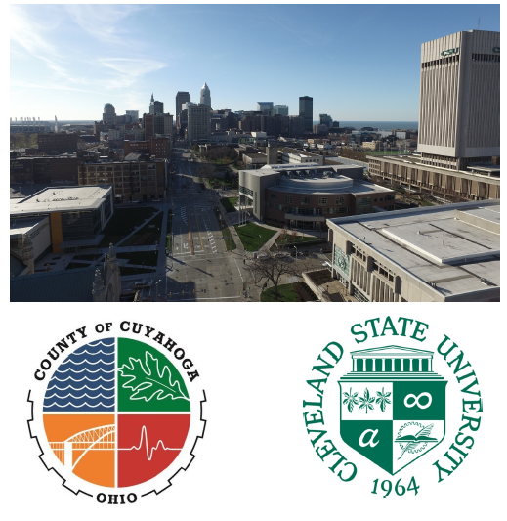
Tuition Assistance Program
Full time employees of Cuyahoga County may be eligible for the Tuition Assistance Program (TAP) offered in partnership with Cleveland State University. Participation with Cleveland State is easy!
- Make an initial TAP payment of 25% of your current semester student account balance before the first day of the semester.
- Upload a copy of your County approved eligibility form.
- Learn AMAZING THINGS in class at CSU!
- CSU will apply a waiver to reduce the cost of your tuition to $300/credit hour (undergraduate) / $425/credit hour (graduate) after successful completion of courses.
- Provide a copy of your transcript to your employer to begin the reimbursement process.
- Pay the remaining balance on your student account within 4 weeks of the end of the term.
The cost of books, course or material fees are your responsibility. No penalties will be assessed on your student account throughout the semester as long as your initial payment was received before the first day of class and your final payment is made within 30 days of the end of the term.

Student Name: _____________________________________ CSU ID: ______________________
Employer: Cuyahoga County Employee ID ______________________
Department: ________________________________________________
Supervisor Name: ____________________________________________
Semester enrolling (circle one): FALL SPRING SUMMER
Career (circle one): Undergraduate Graduate
Program of Study: ____________________________________________
Number of credits: ___________
I have made the initial 25% TAP payment required to participate in the County / CSU Tuition Assistance Program
I understand that any remaining balance for the semester will be due within 4 weeks of the end of classes

_________________________________________________________________________________
Student Signature: Date:

