Budget Guidelines
Fiscal Year 2023-24

Overview
Cleveland State University will begin budget development activities for the 2023-24 fiscal year (FY2024) in December 2022. The guidelines have been developed with a unified goal of year-round planning and analysis, alignment with the University’s strategic priorities, and efficient stewardship of resources and operations. The budget packet including an Executive Summary, FY2023 projections and outcomes assessment and strategic initiate requests are due to budgetoffice_btr@csuohio.edu by February 16, 2023. All materials submitted will be available on TEAMS to the Provost and SVP/CFO. Budget session will be held for Deans and VP’s, February 24 through March 7, 2023.

The FY2024 budget process will be a combination of verifying personnel compensation, review and align PERM (Base) Budget with CSU 2.0, and aligning Strategic Initiative Budget Requests with deliverables in support of the intended outcomes within CSU 2.0.
Integration of the Strategic Planning Process and the Budget Process is driven by CSU’s vision, mission, and academic priorities. Planning drives budget development. The resources of the college advance strategic planning decisions but are also required to support operational planning such as utility costs, salary and benefit increases and capital development program operating costs.
Not all planning requires additional funding. Some plans require a reallocation of resources, new processes or procedures. In some instances, strategic planning efforts may result in a recommendation to allocate fewer resources to efforts. Effective planning looks at all possibilities in attempting to achieve desired outcomes.
Requests for additional ‘net new’ funding should be limited and focused on only those highest-priority CSU 2.0 strategic initiatives. Clearly identify, describe, and justify budget requests. Successful requests will be thoroughly explained, include a budget model and spending plans and well-developed scalable options. Think strategically rather than incrementally, when allocating resources.
Use the Strategic Initiative Planning Worksheet to requests ‘net new’ funding. Include an Executive Summary outlining the request and measurable outcomes. Additional ‘net new’ funding is considered after exhausting base (PERM) budgets, approved carryover budgets and available gifts and grants. Requests must include metrics and milestones to provide key indicators of the initiative’s progress.

Note: Reallocating resources within existing budgets, rather than through requesting additional resources, is a key step toward financial sustainability. To the extent resources are needed, please be sure to consider the budget building cycle as the primary mechanism to identify and request resources, including personnel. Interim requests during the year will only be considered on a strategic and emergency basis.

Figure 1 displays the FY2024 Budget Calendar including due dates and instructions on where to submit spreadsheets and the Executive Summary.

Figure 1
Budget Development Timeline FY2023-24
All dates are tentative and subject to change
December 5, 2022 | ● | Budget memo
December 5 | ● | Fiscal Officer Meeting -Budget Building Kick-off (Session 1)
December 8 | ● | Fiscal Officer Meeting -Budget Building Kick-off (Session 2) Zero-base budgeting for SVP/CFO Direct Reports
December 8 | ● | Budget worksheets available on /budgetbld drive for Self-funded, Auxiliary and SVP/CFO Direct Reports
December 9 | ● | Enrollment projects provided by Enrollment Services
December | ● | Tuition Guarantee Program by Class provided by Institutional Research
January, 2023 | ● | Compensation Model -Define assumptions
January | ● | Tuition Revenue Model developed
February | ● | Partnership agreements
February | ● | Online programs and contracts
February | ● | Scholarship review
February | ● | Fringe rate review
February | ● | Major contracts
February 16 | ● | Due date for self-supporting departments (net neutral budget) evaluate and submit budget updates.
February 16 | ● | Due date for CSU 2.0 Special Initiatives
February 16 | ● | Review Organizational Chart and job descriptions
February 16 | ● | Due date for CSU 2.0 College Realignment budget allocations from Provost's Office
February 16 | ● | Due date for Zero Base Budgets. Areas reporting to SVP Business Affairs and Finance/CFO
February 16 | ● | Due date for Executive Summary including FY2023 Department Report forecast and analysis
February 17 | ● | Executive Summary and budget spreadsheet saved on TEAMS for Provost and SVP/CFO
February 24 - March 7 | ● | Dean and VP budget sessions
March | ● | Overhead rate
March | ● | Master budget spreadsheet balanced
April 3 | ● | Employees on Payroll and Position Control spreadsheets available on /budgetbld drive
April 17 | ● | Due date for Employees on Payroll spreadsheet to be emailed to budgetoffice_btr@csuohio.edu
April | ● | Update tuition and fee schedule
May | ● | Board materials prepared
May | ● | Budget and tuition and fee rates presented to BOT for approval
June | ● | Budget integration to GL
June 2023 | ● | Budget available to departments

Budget Process
FY2023 Executive Summary and Forecast
Due date -February 16, 2023, email to budgetoffice_btr@csuohio.edu.
Provide a brief narrative (approximately 2-3 pages) to accompany your budget submission due on Thursday, February 16, 2023. This narrative is designed to provide divisional and departmental leadership an opportunity to contextualize their financial plans. Narratives will be included in budget packages that will be reviewed with the Provost and SVP/CFO during the budget sessions scheduled for February 24 through March 7, 2023.
- Outline your main goals, challenges, opportunities, and how they align the five targeted CSU 2.0 strategies
- Describe major revenue and expense variances in your December 2022 budget, including significant programmatic changes. You should discuss these in the framework of compensation vs. non-compensation variance and unrestricted vs. restricted funding sources (if applicable).
- Staring with your December 2022 Department Report as a template, forecast revenue and expenditures through the remaining of the fiscal year and determine variances from the TEMP budget at the century (0X00) account ID level. Variances greater than $1,000 or 10% over the century level budget, require an explanation in a ‘Comments’ column.
- Measure and asses performance by assigning key performance indicators (KPI’s). Identify and track financial commitments and goals.
- Include a clear description of how endowment and gift balances (if applicable) will be deployed in the coming fiscal year. Prioritize and highlight funds that may have accumulated balances in your planning.
- For areas with material sponsored activities, describe significant changes in grant portfolio composition or volume from FY2023 (shifting sponsor composition, significant new awards or awards ending, etc.)
- Due date -February 16, 2023, email to budgetoffice_btr@csuohio.edu.

Figure 2
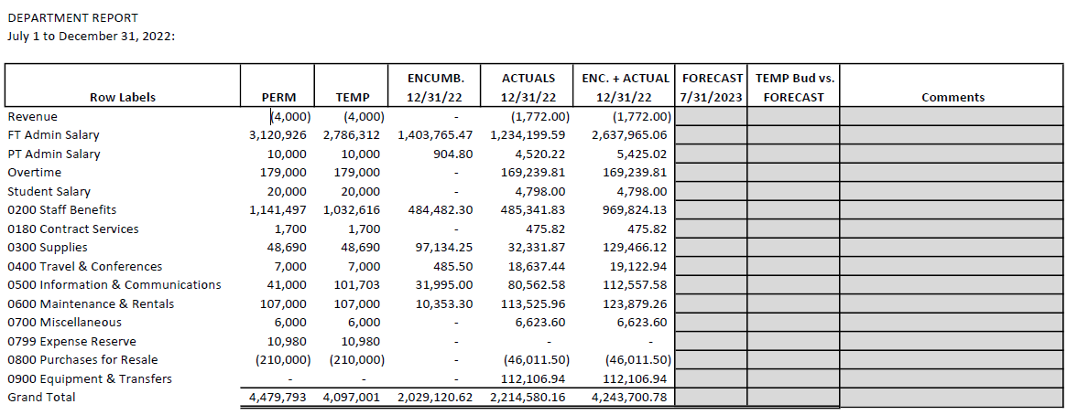

FY2024 Employees on Payroll and Position Control
Due date -April 17, 2023, email to budgetoffice_btr@csuohio.edu.
The Budget Building Spreadsheet will focus on Employees on Payroll (EP) and Position Budget (PB) tabs. The EP tab is used to indicate if an employee will continue in FY2024. There is also an option to indicate if an employee is eligible for an increase when a contract crosses a fiscal year, but not extended.
Departments PERM (Base) budget should be reviewed and aligned in support of CSU 2.0. The regular Budget Transfer Request (eBTR) process will be used for operating budgets transfers.

Zero-Based Budgeting
SVP/CFO Direct Reports
Due date -February 16, 2023, email to budgetoffice_btr@csuohio.edu.
Zero-Based Budgeting (ZBB) is a budget model in which all expenses must be justified starting from zero. It is a “Start from Scratch” budget methodology in contrast to an incremental budget model. ZBB calls for justification for existing, recurring, onetime and new expenses. Each budget line item is reviewed without influence of previous periods actuals as a baseline.

The purpose of ZBB is to analyze and justify every expense. A determination is made if an expense should be reduced, removed, maintained or increased. All elements of the budget need to be accounted for to identify cost-effective, relevant and cost-saving areas.

Process:
  - Start by running a 3-5-year history GL Data Extract out of PeopleSoft, by Department, by Account
  - Then run a Transaction Register (TR) for the same periods to review each expense. Then decide if these expenses are still needed (recurring) or if they can be discontinued.
    - Are there any new expenses that are needed? If so, why?
  - As always, for any questions/concerns, please contact a member of the budget department and you can also always email budgetoffice_btr@csuohio.edu

FY2024 CSU 2.0 Strategic Initiative Planning Worksheet
Due date -February 16, 2023, email to budgetoffice_btr@csuohio.edu.
Requests for ‘net new’ funding should be made on the CSU 2.0 Strategic Initiative Planning Worksheet. You can find the worksheet on the Budget and Financial Analysis website, the budgetbld (\\vike) (S) shared drive and Microsoft Teams, Fiscal Officer Group. Use the Instructions tab located at the bottom of the worksheet to guide you on completing the Input spreadsheet.
Information regarding strategic themes and the 24 strategic priorities can be found at https://csu2.0.csuohio.edu. Allocation of resources will be aligned with the strategic initiatives outlined in CSU 2.0
The budget request should include dependencies such as personnel costs, supply and expense, technology and minor renovation required in support of the initiative. Include revenues that will be generated as part of the initiative. Use the Account Code in Column L of the spreadsheet to indicate the nature of the revenue or expense.
Personnel requests:
- Attach an organizational chart of the department structure and the requested position(s) placement within the structure.
- Attach a job description using the Job Description Template located on the Human Resources website under Forms for Professional Staff. Faculty positions requests should be made through the Provost’s Office.
- Fringe rates for 2023 are currently be evaluated and will be released shortly. Use the 2023 rates below when for calculating FY2024 fringe.
  - Full-time 34.50%
  - Part-time 20.25%
Information technology (IS&T):
- Does the request include funding for any IS&T related costs including hardware, software (including cloud-based services), contracts or staff? Check pricing on Magnus Mart or contact IS&T.

Supply and expense:
- Does the initiative require a supply budget such as office or program supplies?
Minor renovation:
- Minor renovations cost under $100,000 and include modifications to a building such as finishes or changing parts of the building. It does not include structural alterations or changes to the building footprint. Consideration of start-up budgets should be reviewed prior to requesting additional funding for minor renovations.
Metrics and Milestones:
- Describe and quantify using metrics, the specific performance outcomes you expect from this funding change.
- What outcomes and results, either positive or negative will occur? What undesired results are reduced, eliminated or mitigated? Explain how efficiencies are optimized.
- Include incremental performance metrics and milestones to mark significant changes or stage in development of the project.
Intercollegiate Impacts:
- Identify stakeholders and intercollegiate partners impacted by this proposal. Identify opportunities for sharing of resources and complimentary support.

