**Position Paper & Presentation Instructions**

Throughout this class we will review new and interesting business topics. You must select one of these topics to research and present support for a particular position. This paper should **not include any opinion**, instead this report provides a well-researched and supported position on the business practice. Please pay close attention to the position you choose. If your position is that the gig economy is good for society, but you discuss evidence that shows how the gig economy helps business owners, then you will lose points. A counter argument and a **minimum of three sources** are expected.

The following format is encouraged:

**Paragraph 1 – Introduction:** You may expect your audience to have read the article. This paragraph should discuss the controversy of the business practice, summarize your position, the support for your position and the counter argument.

**Paragraph 2 - Support 1:** Using outside **reliable** sources, clearly explain how your position is supported. Provide quotes and statistics when possible. Try to make coherent and convincing arguments, using the strongest evidence you can find.

**Paragraph 3 - Counter Argument:** You must address the opposing position. This is where you may need to play devil’s advocate. Consider and describe the evidence the opposing side may use to support their position. Include this information fairly.

**Paragraph 4 - Support 2:** As with paragraph 2, use the most convincing and strongest evidence to support your position. You may include this paragraph directly after paragraph 2, or you may write this paragraph after the counter argument and address the issues presented in the counter argument.

**Paragraph 5 – Conclusion:** Summarize your strongest points here, as well as the counter argument. Discuss why the counter argument does not change your mind. New evidence should not be presented in this paragraph, instead, clearly and concisely describe how your position is supported.

--

This paper is designed to be 500 – 700 words. Through, this is only a guide. If the position is supported well in less than 500 words, that is fine. If it takes a little more than 700 words, that is fine. Points will be deducted for content; the word count is only a guideline.

The organization of the report and writing style is important and will be a major factor in scoring. Specifically, you will be graded on the following criteria:

* **Organization of report.** Report is professional with an easy and logical flow from one concept to another. External sources are properly cited.
* **Writing Style**. Writing is clear and persuasive. The appropriate technical and business terms are used. The report is well edited, containing fewer than 5 spelling or grammatical errors.
* **Accuracy, relevance and clarity of statements and analysis.** The analysis is creative and fully thought-out; findings and support are clearly interpreted and explained.
* **Logic and reasoning; ability to support position with data.** The position should be thought-provoking and compelling. Proposals and evidence are presented logically and is well-supported.

At least **three outside sources** are needed for this paper. You may include our class textbook (or any previous course textbooks you have used) as a source, but you must properly cite all of your sources using APA style, both in the text (Last name, year) and in a References section (a new page is not necessary, but a heading is needed).

Websites that may help:

<https://writingcenter.fas.harvard.edu/pages/counter-argument>

<https://owl.purdue.edu/owl/research_and_citation/apa_style/apa_formatting_and_style_guide/general_format.html>

Grading rubric:

|  |  |  |
| --- | --- | --- |
| **Position Paper** | | **Possible** |
| Content | |  |
|  | Introduction | 1 |
|  | Support (three credible sources) | 6 |
|  | Counter Argument | 1 |
|  | Conclusion | 2 |
| Presentation |  |  |
|  | Length and Speed | 3 |
|  | Style of video | 3 |
|  | Organization of material | 2 |
|  | Interacting with audience | 2 |
| Report |  |  |
|  | Organization of report | 2 |
|  | Writing style | 4 |
|  | Accuracy, relevance, and clarity | 2 |
|  | Logic and reasoning | 2 |
| Total | | **30** |

**In addition to the paper, you must also present the position to the class.** Please present a 1-2-minute video to the course discussion board. You are **not** expected to speak in the video, in fact, I prefer information videos without speaking (though, music is fine). I would prefer the video is not a screen recording of a PowerPoint presentation. Instead, please check out some of the free software tools available online! These tools require you to sign-up for a free account. Here are a few I know about, but you are welcome to use anything.

* Adobe Spark – This one is my favorite. Very easy to use, set up similar to powerpoint, and you download the video onto your computer. <https://spark.adobe.com/sp>
* Powtoon – Pretty easy to use, I suggest starting with a template. You cannot download the video, you must upload to YouTube. It is still easy to upload to Blackboard though. <https://www.powtoon.com/my-powtoons/?#/>
* Biteable – This one seemed very slow so I did not like it as much. You would need to upload to You Tube and some of the rendering took 15 minutes. <https://biteable.com/>
* Moovly – This one was my least favorite. It required a lot more work and was difficult to use a template. However, perhaps if you have previous video experience then you may like it. <https://www.moovly.com/>

**As an added bonus - the best video of the week will earn 5 points extra credit!!**

A couple notes about the way the video presentation will be scored:

*Length and Speed* – The presentation should be between 1-3 minutes and presented in a way that is easy to read. If there is text on the screen, then we should have enough time to read it.

*Style of video* – Please use appropriate graphics, colors and fonts. There should be more to look at than just text. Text should be easy to read. The whole presentation should be consistent and coordinated.

*Organization of Material* – The presentation should move from one point to another in a logical way. The position should be clearly articulated.

*Interaction with audience* – As the class comments on the video, please address the comments, answer questions, and otherwise facilitate a discussion.

**Tips for using Adobe Spark:**

Use the FREE plan:

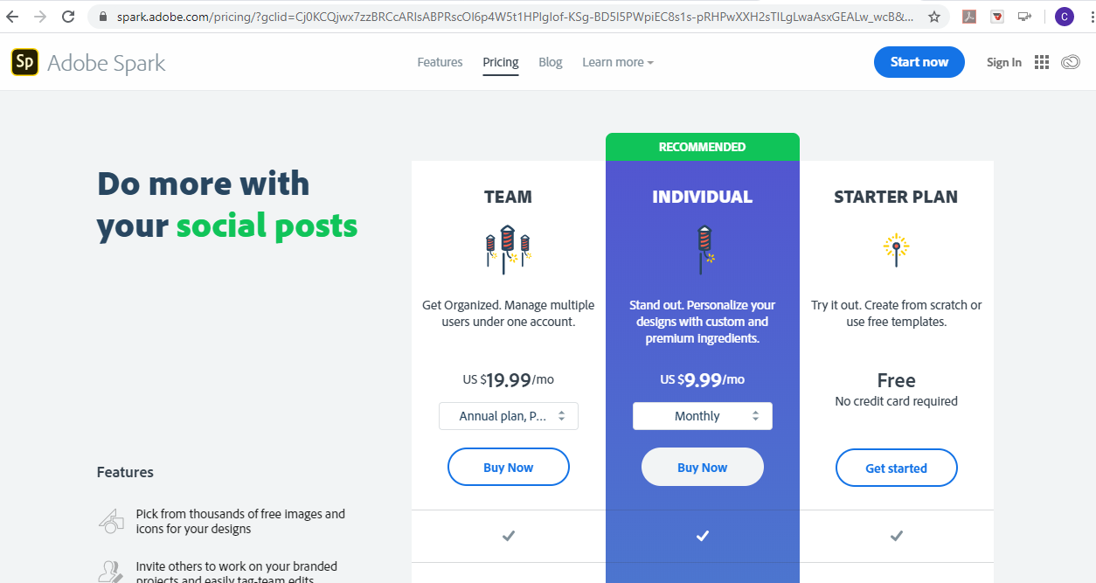

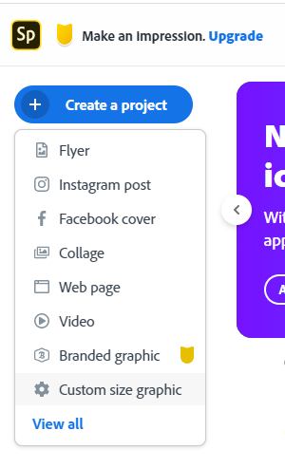Once you are logged in and “home” (spark.adobe.com), scroll down to “Short Videos” and click “Create a Video”.

The next screen should have a blue button, “Create a Project”. Click it, then select “Video” from the drop down box. (see the image to the left)

Then you will name the video and choose a template. You can watch a video telling you how to make a video (I did not) or you can just jump right in by clicking “OK, I’m ready!”

**Tips for using Powtoon**

I have seen some really nice powtoon videos too. As with Spark, use the free account. Then click the big blue “Start Now” button on the homepage.

I recommend at least beginning with a template in Powtoon. There are some really neat ones! I liked the “infographics” group. The “Presentation” group of templates is most like powerpoint, so if you are hesitant about using a new program, then these might be a better fit for you.

**Uploading to Blackboard**

Finally, you will need to upload to the Discussion Board. This is easier than it sounds. I will show you how I uploaded my Adobe Spark first, then how to upload from YouTube. (See next page)

1. Enter the discussion board and click “Create Thread” (circled below in red): 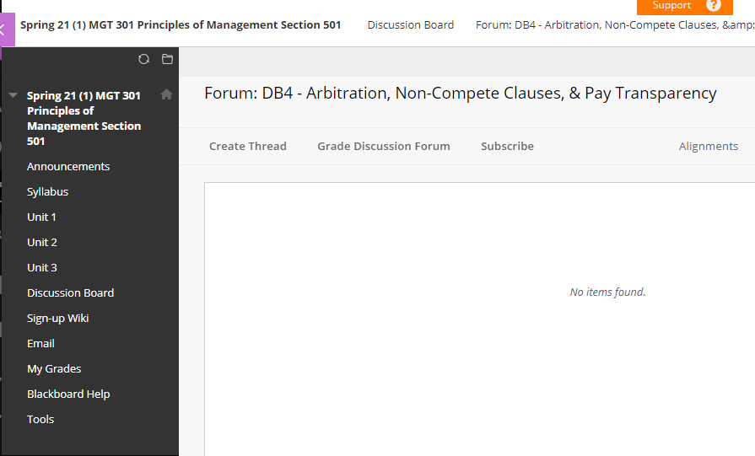
2. Enter a subject (your position – see instructions) and then click the insert button (circled in red below): 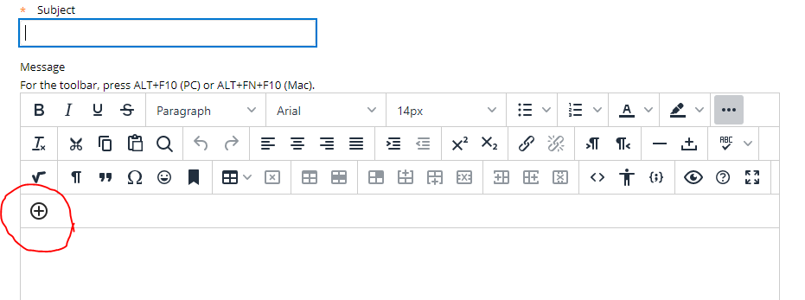
3. If you are uploading from your computer, then select “Insert Local Files”, circled in red below. If you are uploading from YouTube, then skip down to step 6.

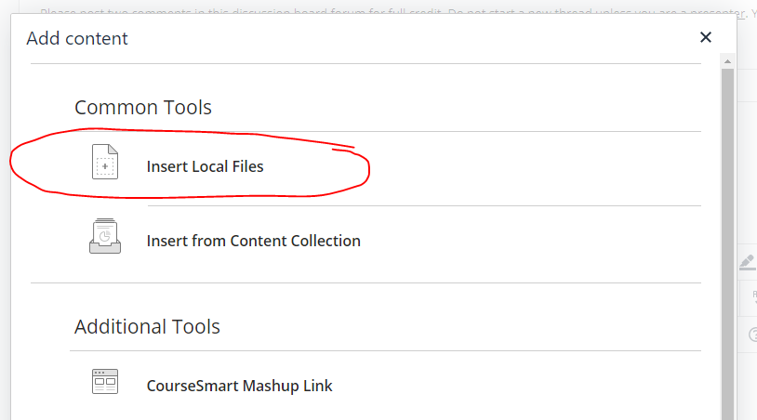

1. Select the file from your computer and the file will begin uploading (the file is uploading so It might take a minute). You will see the video preview below. You may change the dimensions if you like (though not really necessary), but make sure the “Constrain Proportions” is checked. Then click “Insert”.
2. You will return to the Create Thread page. You may see the video, or you may see a yellow box where the video will be, either way is fine. Click “Submit” to post to the Discussion Board.

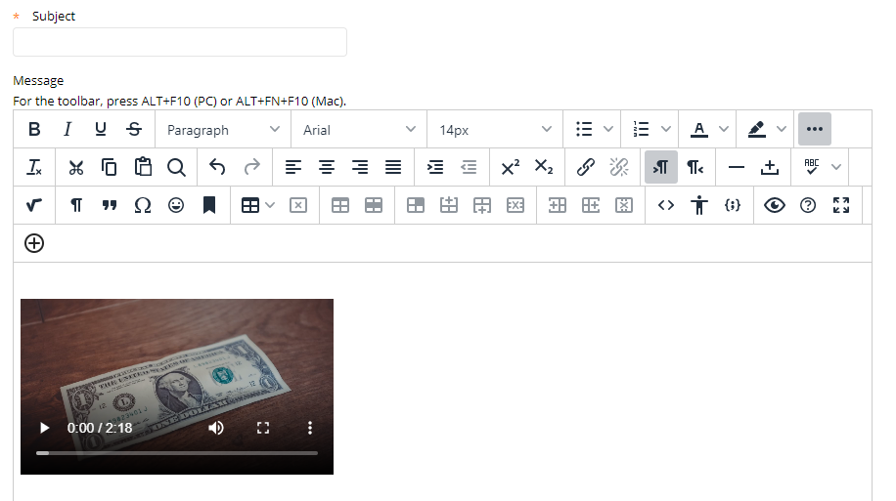

1. If you are posting something from You Tube complete steps 1-3 above. Once you click the insert media button (plus sign), scroll down in the pop-up box and select “YouTube Video” (circled in blue below):

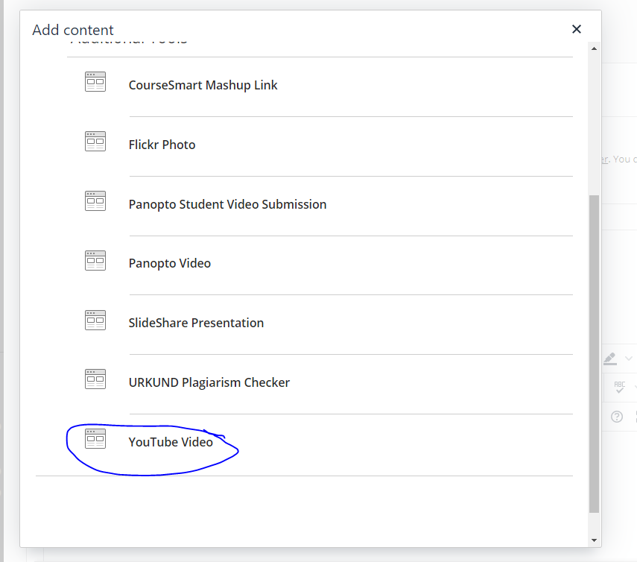

1. Search for you video. If you don’t find it right away, then you can filter the results by when the video was uploaded. Click “Select” when you found your video:

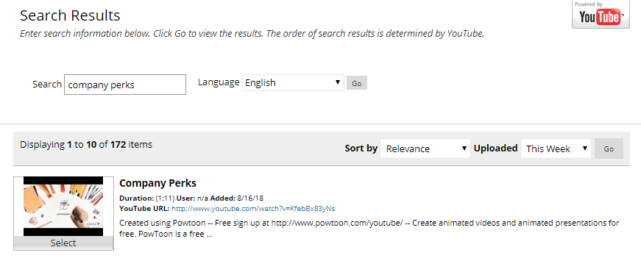

Click “Submit” on the next screen, where you will see other options and details. You will be returned to the Create Thread page (see below). Click “Submit” to post.